Student Name : Ivan Chong Jia Hao

Student ID : CT0362330

Date : 31 july 2023

Evaluation :

Menu Option 3 : SPCC ( RAN OUT OF TIME TO COMPLETE )

I have partially completed SPCC . But insufficient time to complete.

Menu Option 2 : WORKING

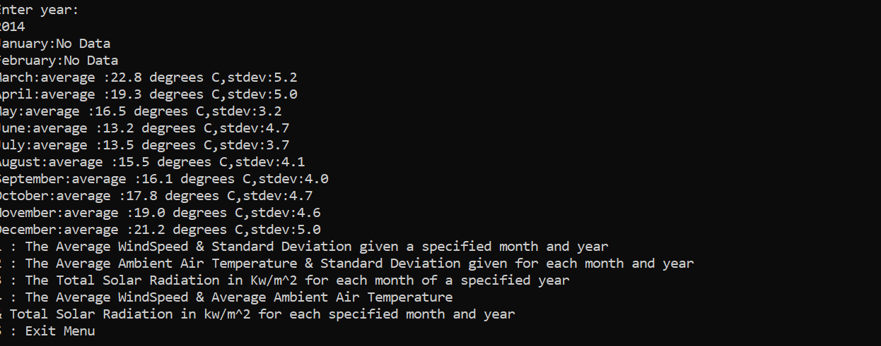

Loading 4 or more files (WORKING

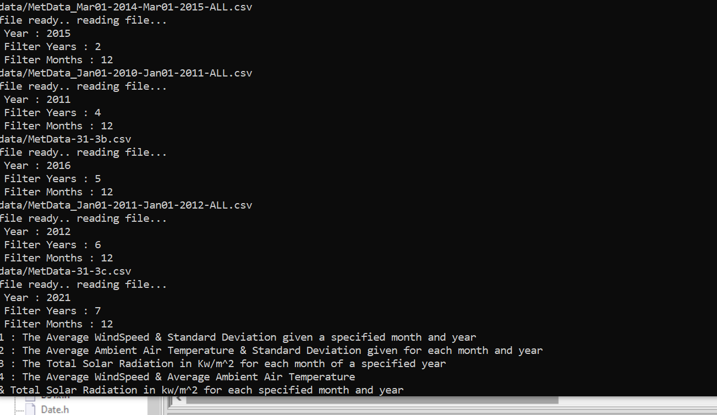

Menu Option 4 : Working

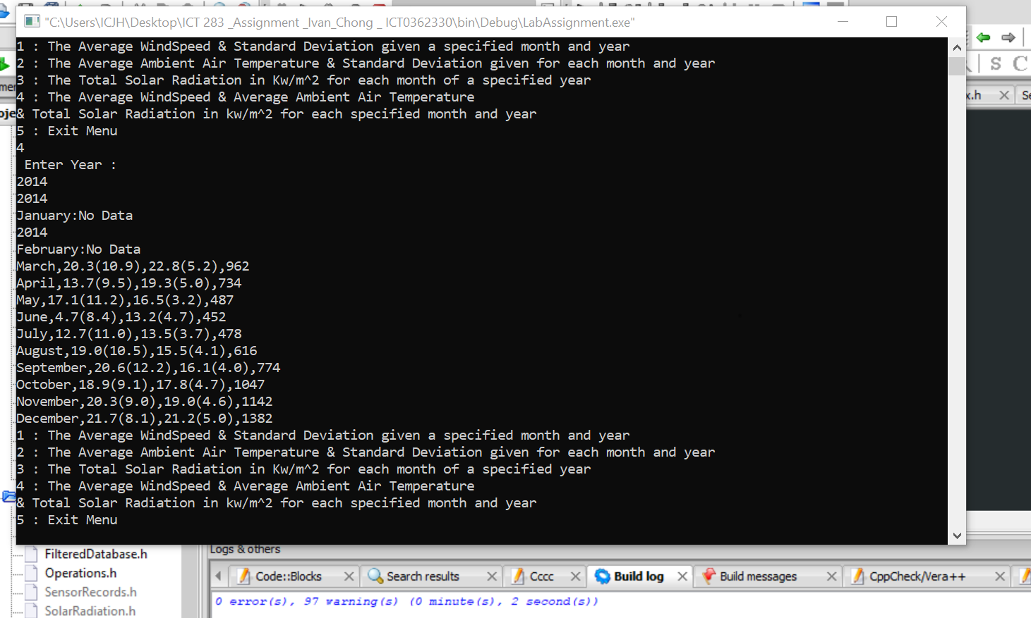

Menu 1 Option : Working

